**DATA MINING AND VISUALIZATION LABORATORY**

**2. Experiment using WEKA tool.**

**Consider the following data set.**

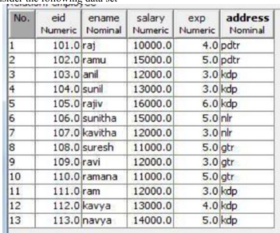

**i). Use the data sources, like ARFF, XML ARFF files.**

**Prepare Dataset in ARFF Format:**

@relation employee

@attribute eid numeric

@attribute salary numeric

@attribute exp numeric

@attribute address {pdtr,kdp,nlr,gtr} % class attribute

@data

101.0, 15000.0, 4.0, pdtr

102.0, 15000.0, 5.0, kdp

103.0, 12000.0, 3.0, kdp

104.0, 13000.0, 6.0, kdp

105.0, 13000.0, 4.0, kdp

106.0, 14000.0, 6.0, nlr

107.0, 15000.0, 5.0, nlr

108.0, 12000.0, 3.0, gtr

109.0, 12000.0, 3.0, gtr

110.0, 13000.0, 4.0, kdp

111.0, 13000.0, 4.0, kdp

112.0, 14000.0, 5.0, kdp

113.0, 14000.0, 5.0, kdp

**Note:- Save file as employee.arff**

**Load Data in WEKA**

* Open **WEKA Explorer**.
* Click **Open file**, select your employee.arff.

**After Preparing the Dataset Do the following:**

**a). Classify , Invoke MultiLayerPerception.**

**b). Build neural network GUI as below .**

**Build Neural Network**

* Go to the **Classify** tab.
* Choose **Classifier > functions > MultilayerPerceptron**.
* Click **Start** to train with default parameters.
* View output, such as accuracy, confusion matrix.

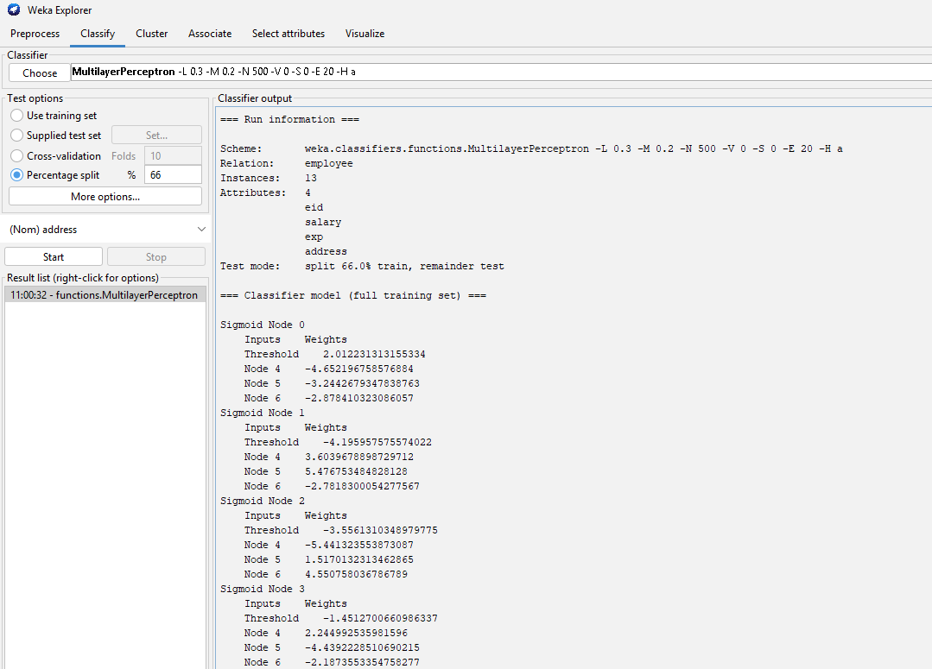

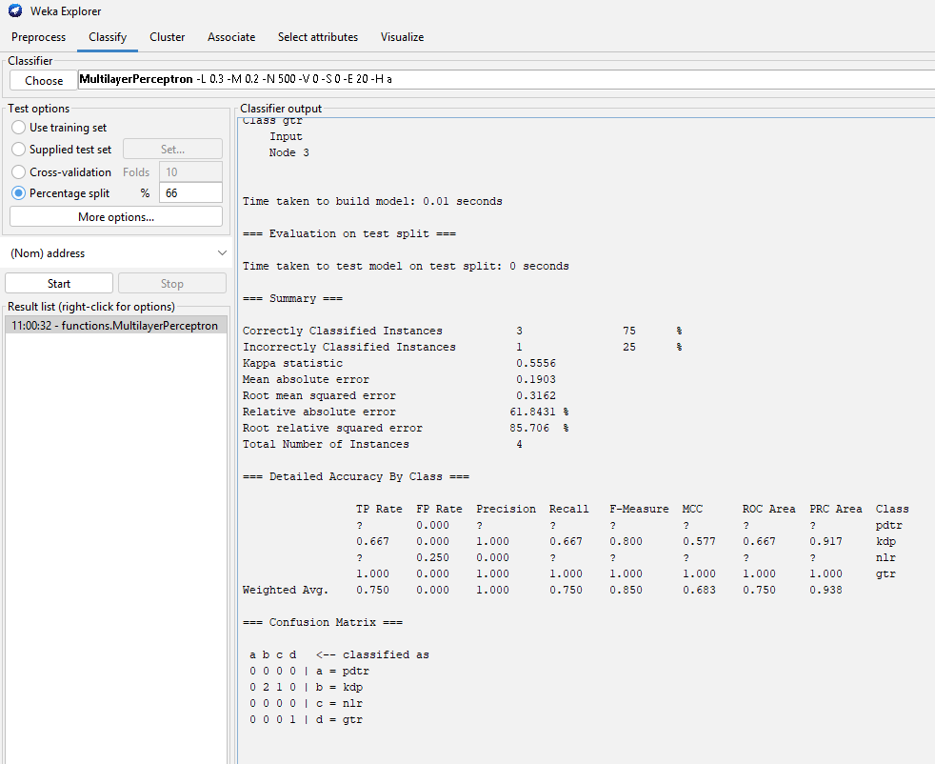

**ii) Beginning the process of editing the network to add a second hidden layer**

**Edit network architecture:**

* Click on the **MultilayerPerceptron** name → press **Edit**.
* In the “Hidden Layers” field, type a,a (meaning 2 hidden layers, each with number of nodes equal to (attribs + classes) / 2).
* Alternatively, specify exact nodes, e.g., 5,3.
* Click **OK** and **Start**.

**iii) The finished network with two hidden layers.**

* Check output for improved accuracy and structure.

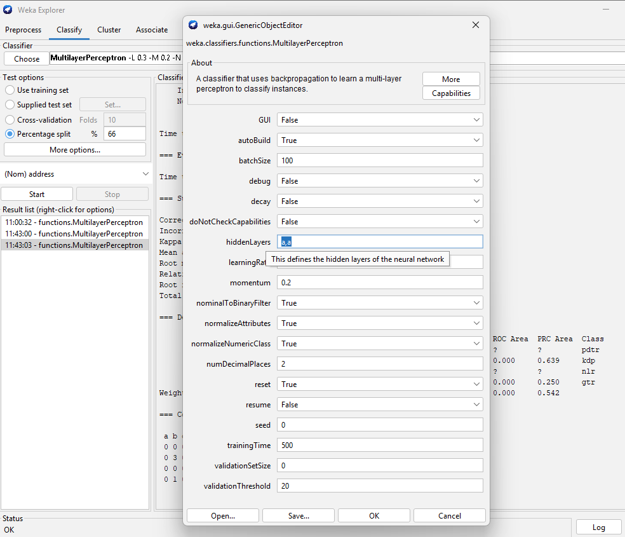

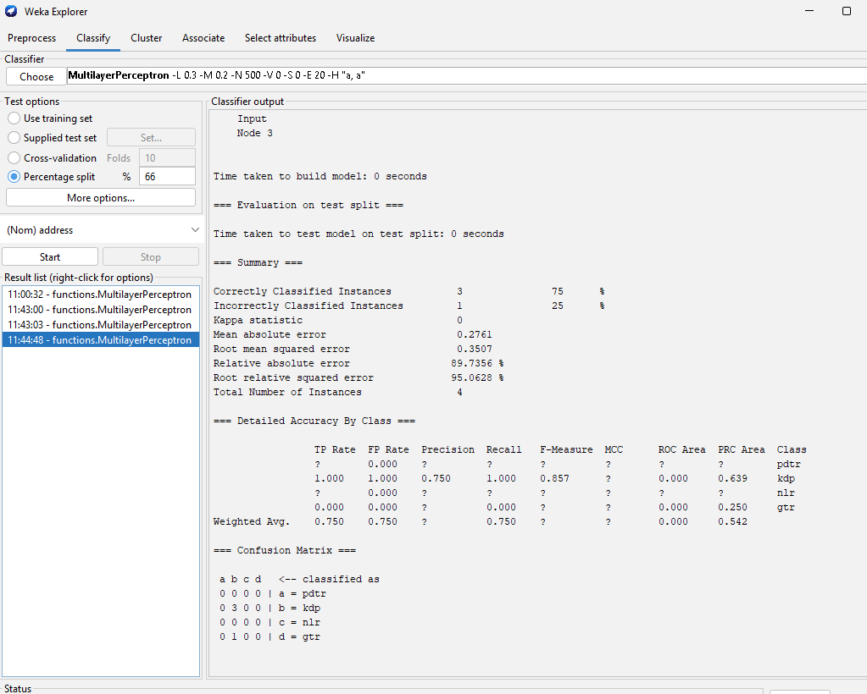

**iv) Apply Lazy classifier, multi instance classifier.**

**Lazy Classifier**

* Go to **Classify** tab.
* Choose **lazy > IBk** (k-NN).
* Click **Start** to train.

**Multi-instance Classifier**

* WEKA’s **multi-instance classifiers** are available under **mi > MultiInstance...**.
* Load dataset suitable for multi-instance (typically requires different format).
* Use **multi-instance** options if applicable.

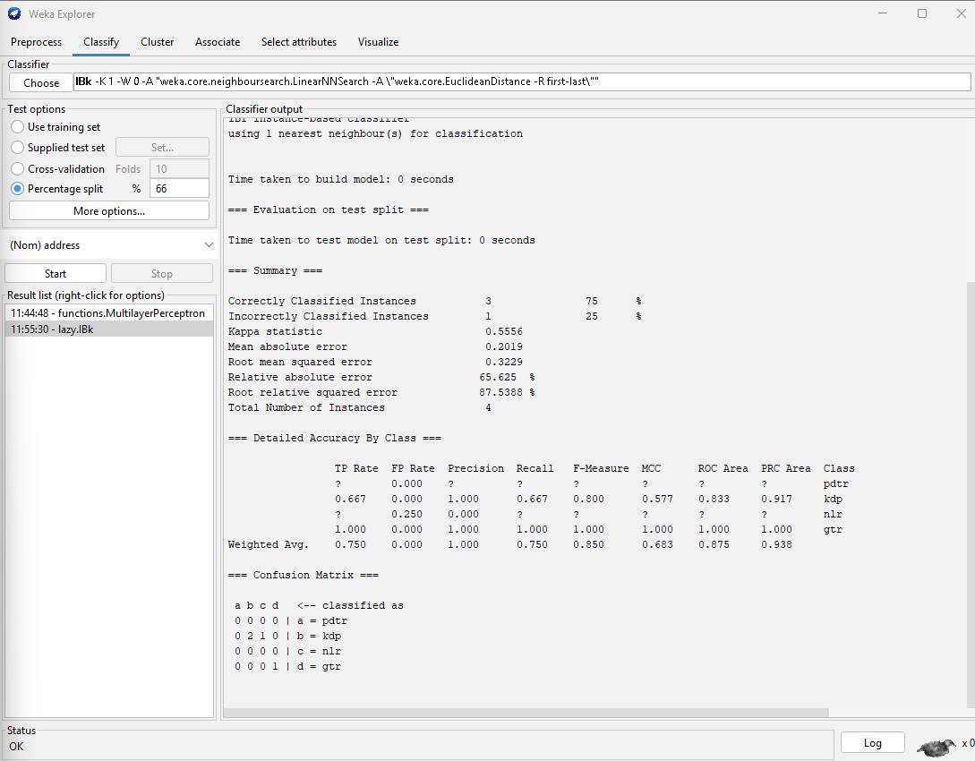

**v) Apply any MetaLearning Algorithm.**

**Meta Classifiers**

* Under **Classify**, select **meta**.
* Examples: **AdaBoostM1**, **Bagging**, **Stacking**.
* Select one, e.g., **AdaBoostM1**.
* Set base classifier (like J48).
* Click **Start**.
* **AdaBoostM1:**

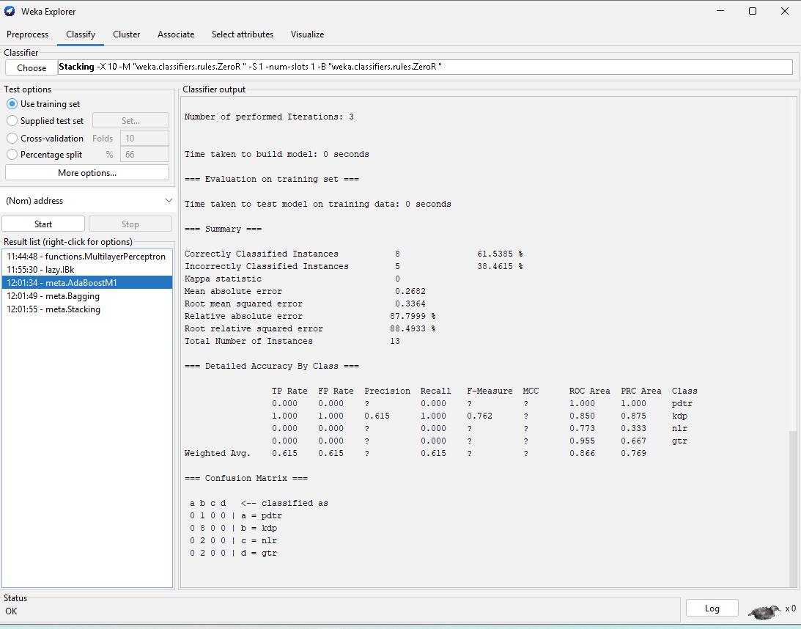

* **Bagging:**

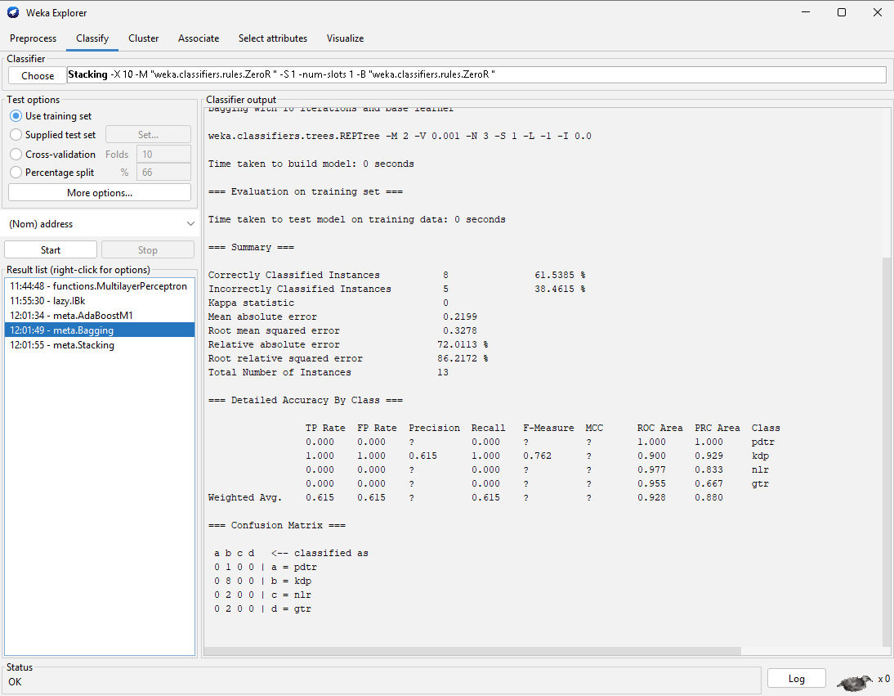

* **Stacking:**

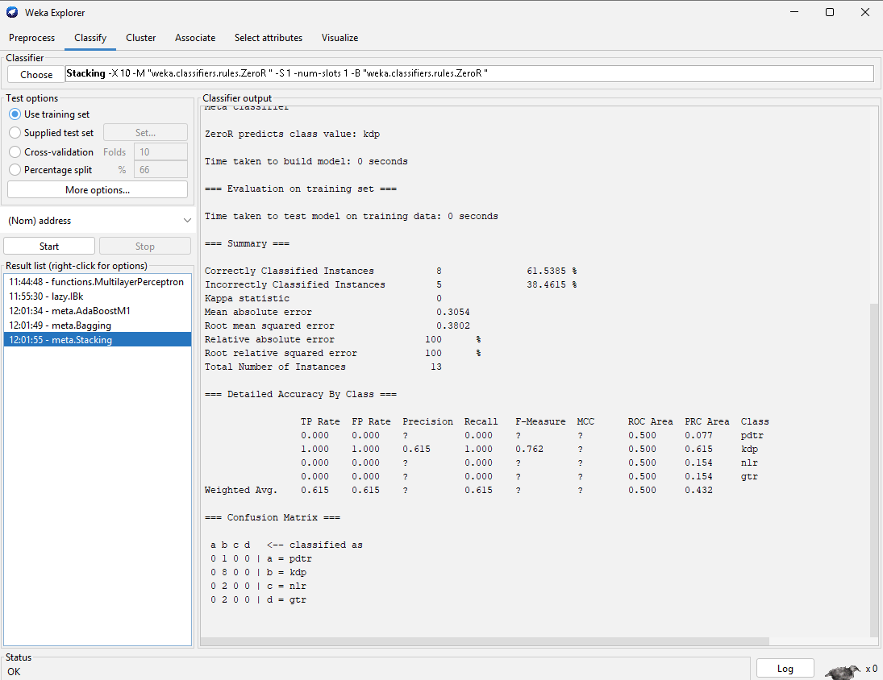

**vi) Optimize base classifier’s performance.**

Use **Grid Search** or **CV Parameter Selection**:

* Go to **Tools > CVParameterSelection**.
* Choose base classifier (e.g., MultilayerPerceptron).
* Select parameters to tune (e.g., learning rate).
* Run to find optimal parameters.

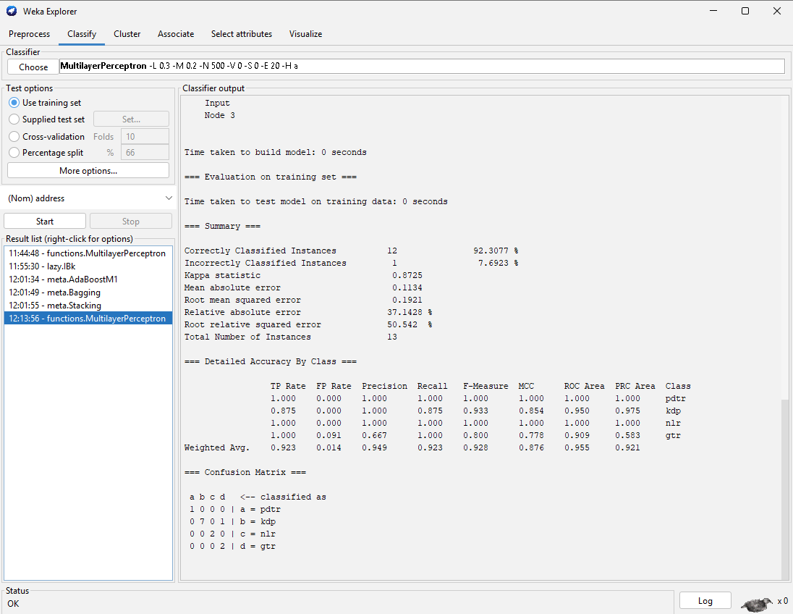

**vii) Use clustering algorithm such as Cobweb, and Hierarchical Cluster.**

Clustering:

* Go to **Cluster** tab.
* Select **Cobweb**.
* Click **Start** to cluster dataset.
* Repeat with **HierarchicalClusterer**.
* View clusters formed.
* **Cobweb:**

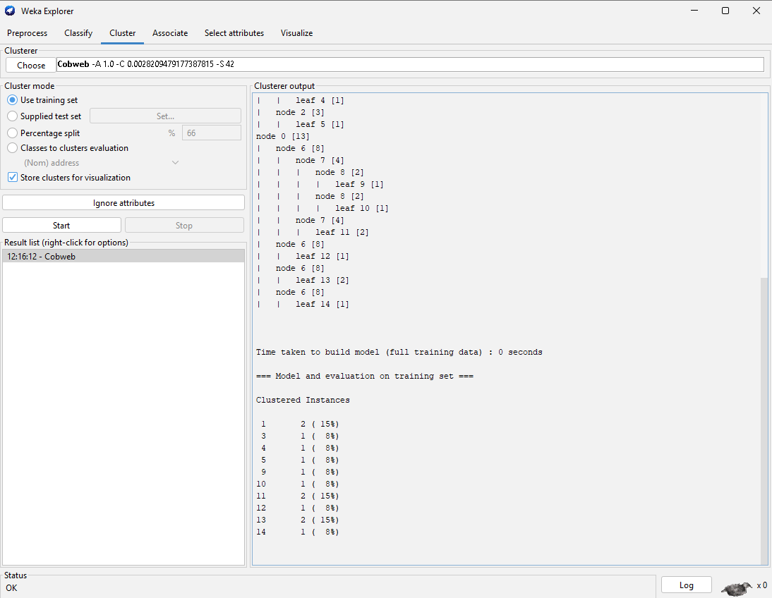

* **HierarchicalClusterer:**

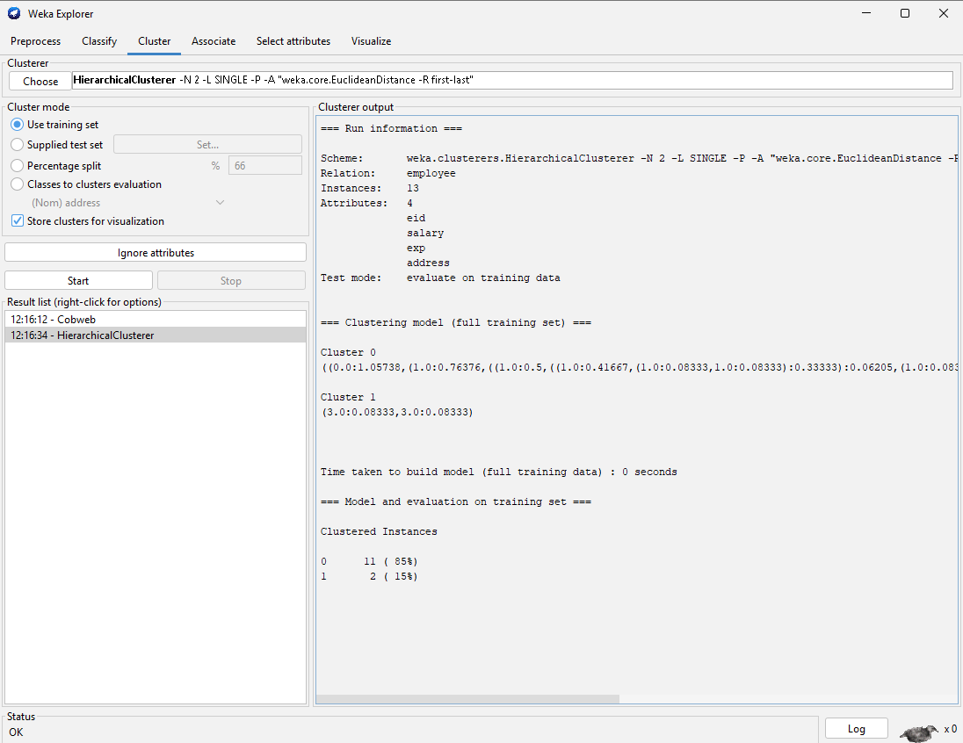

**viii) Select attribute by specifying an evaluator and a search method.**

**Select Attributes**

* Go to **Select attributes** tab.
* Choose evaluator: e.g., **CfsSubsetEval**.
* Choose search method: e.g., **BestFirst**.
* Click **Start** to select important attributes.

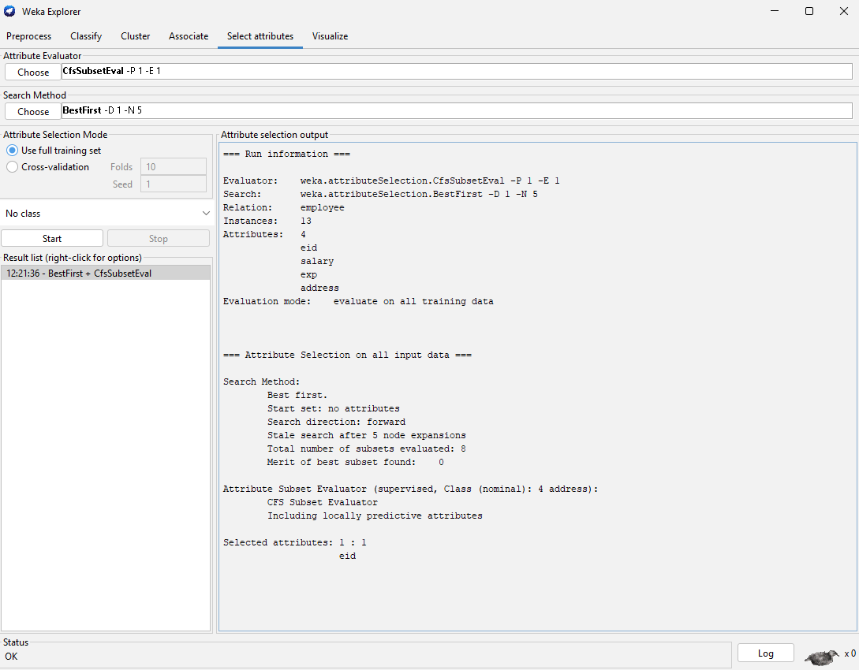

**ix) Insert 30 more records in this file. Perform clustering on this new dataset. Identify optimum number of clusters. After identification of optimum number of clusters, prepare clustering on this number.**

* Edit your ARFF file to add 30 new employee records.
* Reload dataset in WEKA.
* Use clustering algorithms (e.g., **EM**, **k-Means**) to find clusters.
* Use **Cluster evaluation** to identify optimum number of clusters (e.g., look for highest silhouette score or lowest within cluster sum of squares).
* Perform clustering with optimum clusters.

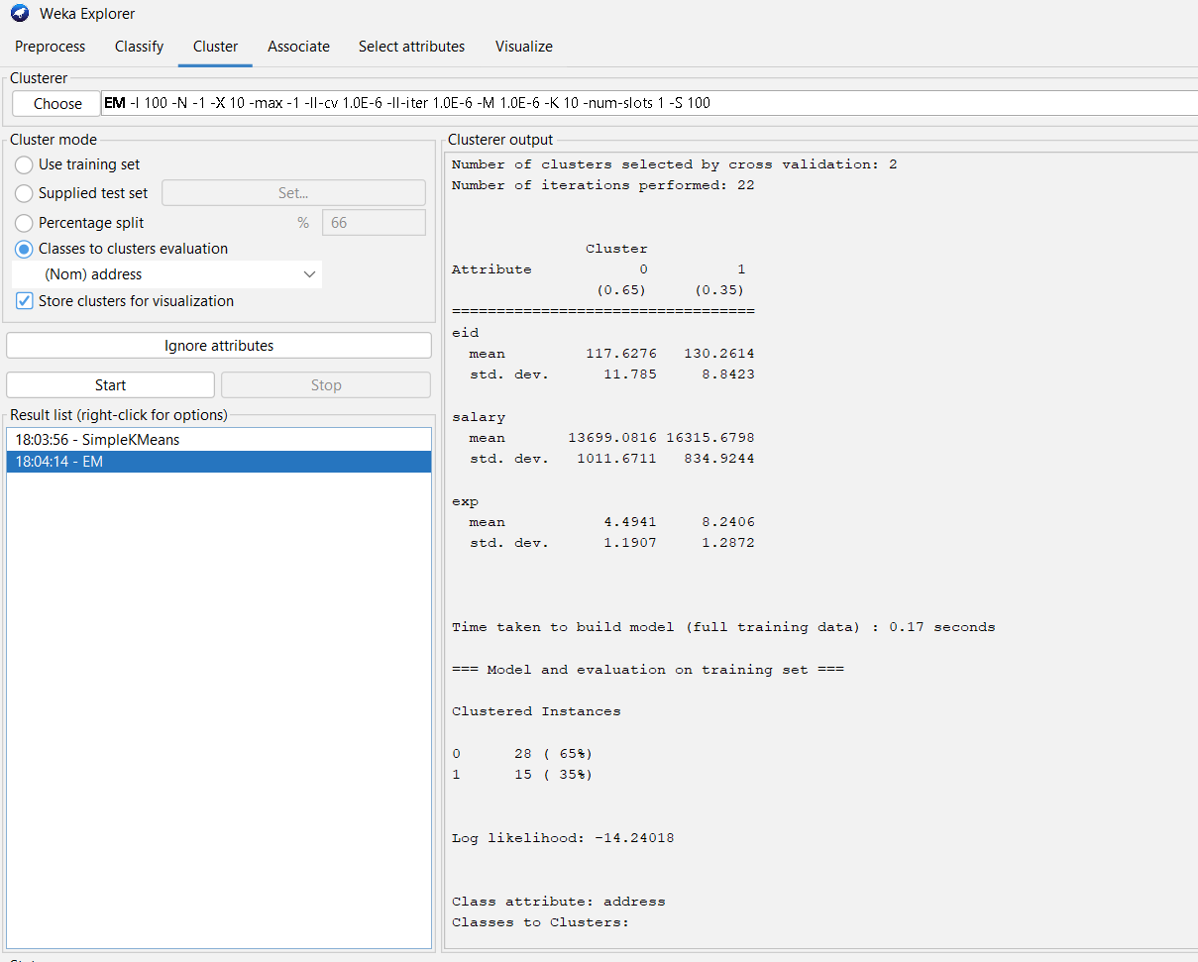

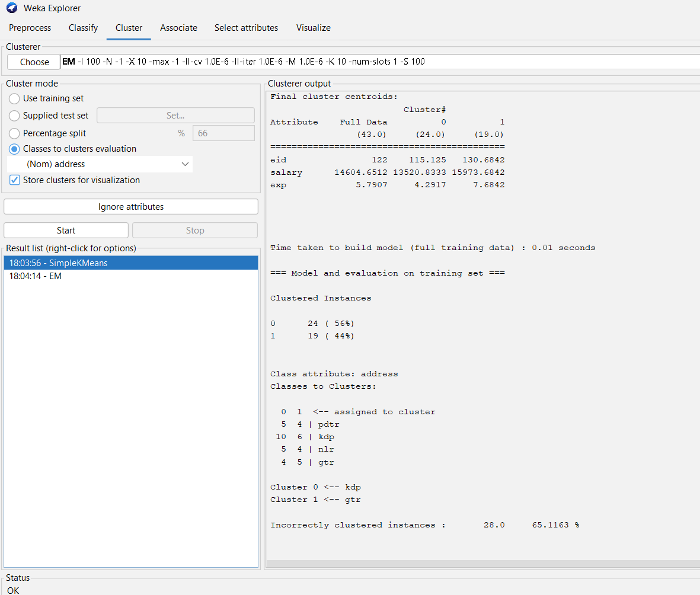

**x) Perform data analysis on the result obtained and prepare an analysis report for the same.**

**Analyze Results**

* Review output clusters.
* Compare clusters with domain knowledge.
* Identify patterns (e.g., clusters by salary or experience).
* Prepare summary report discussing:
* Cluster characteristics.
* Accuracy of classifiers.
* Attribute importance.
* Insights for decision-making.

**Result Analysis – Employee Dataset**

1. Algorithm Used: K-Means (k = 4)

2. Attributes: salary, experience, address

3. Cluster Summary:

* Cluster 1: Low salary (₹12k–₹13k), 2–4 yrs exp, kdp region
* Cluster 2: Mid salary (₹14k–₹15k), 5–6 yrs exp, pdtr region
* Cluster 3: High salary (₹16k–₹17k), 7–10 yrs exp, nlr/gtr

4. Key Patterns:

* Salary increases with experience
* Address influences salary range

5. Attribute Importance:

* Experience → highest impact
* Salary → moderate impact
* Address → low impact

6. Insights:

* HR can use results for pay scale design and promotions
* Useful for identifying training and career growth paths

7. Conclusion:

* Clustering logically grouped employees by experience & region

**Clustering Algorithm**

* Go to the **“Cluster” tab**
* Choose algorithm:
* Cluster mode: Use training set
* Choose → SimpleKMeans
* **Click “SimpleKMeans” and set**:
* Number of clusters (k) = 4
* Distance function = Euclidean
* Keep other options default

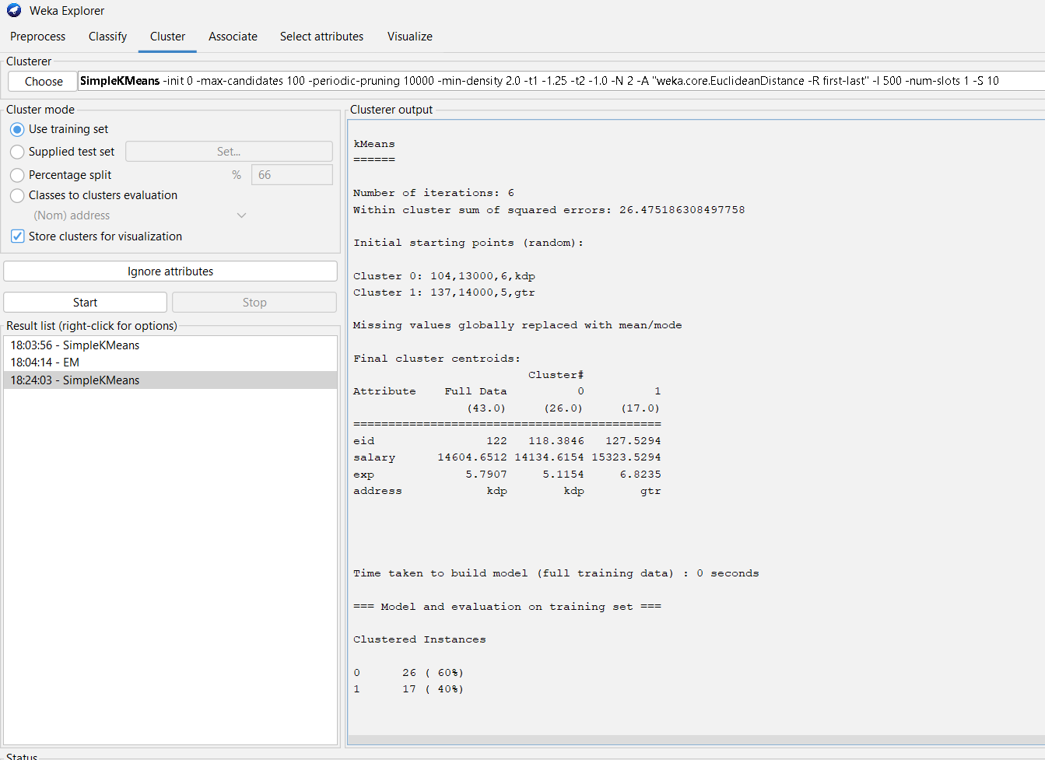

**Visualize the Clusters**

* Click **“Visualize”** to view graphs (e.g., salary vs exp, color-coded by cluster).  
  → You’ll see natural grouping — higher salary with more experience.

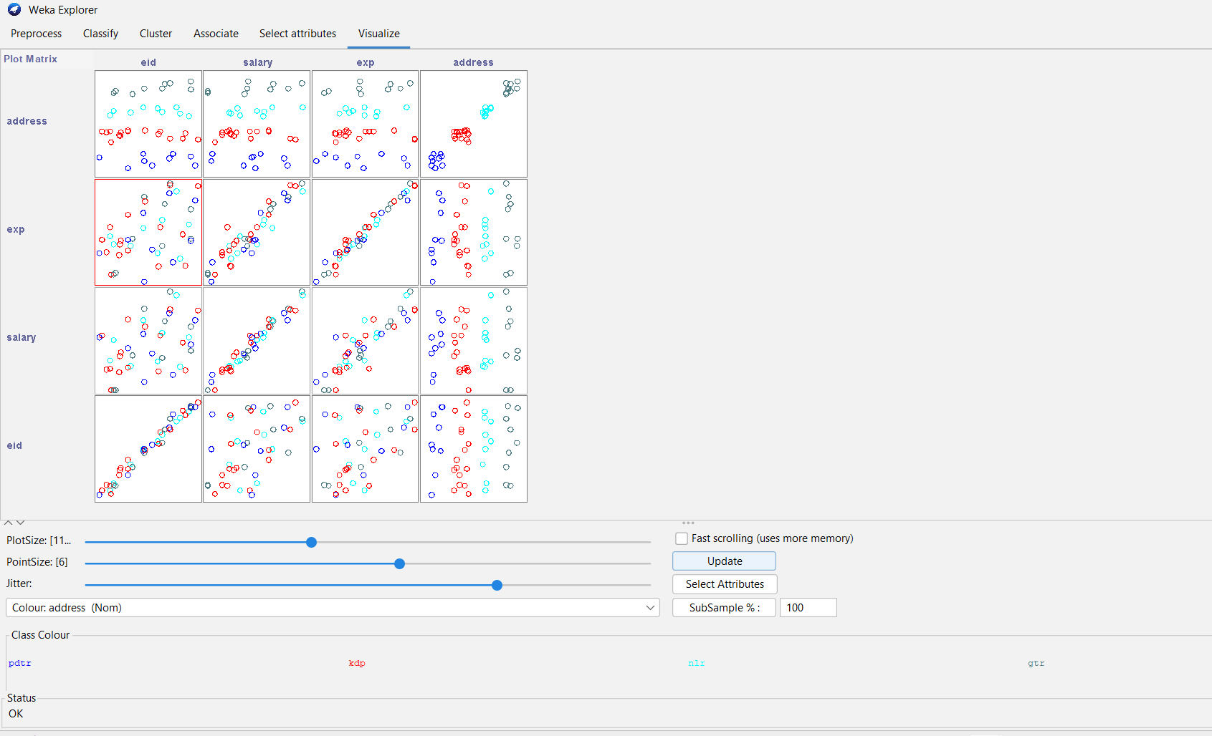

**Evaluate with a Classifier:**

* Go to Classify tab
* Choose algorithm → e.g., J48 (Decision Tree) or NaiveBayes
* Set class attribute = address
* Click Start → You’ll get accuracy %, confusion matrix, and attribute importance.

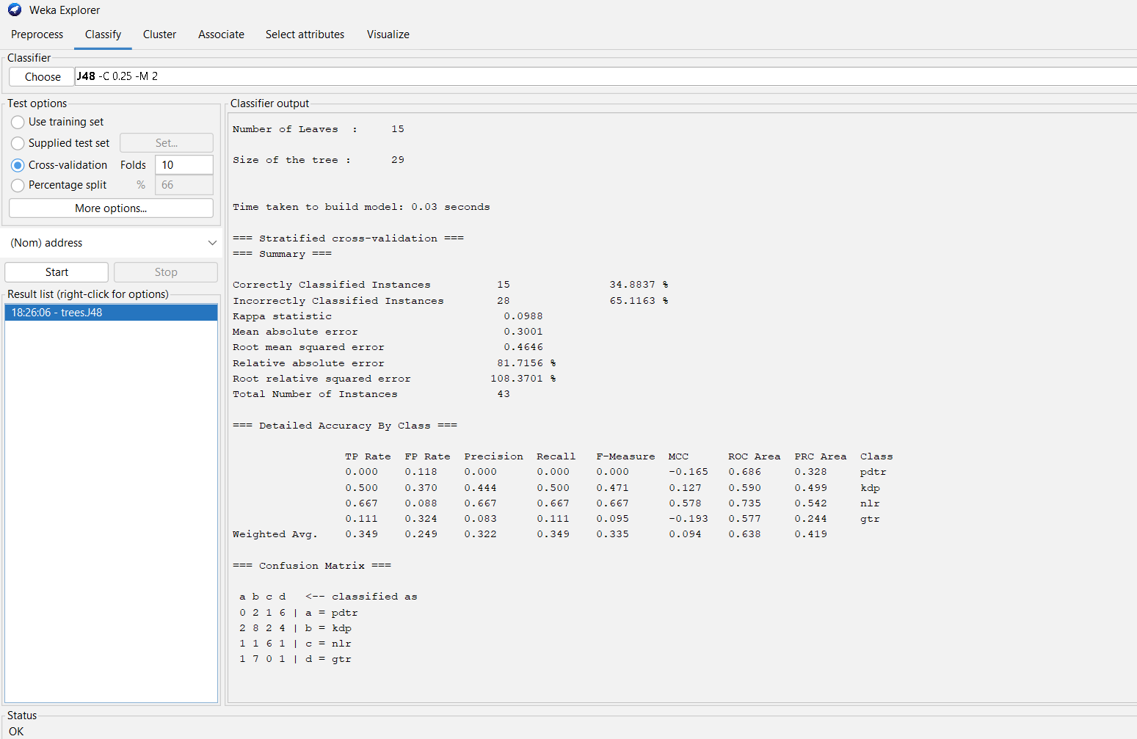

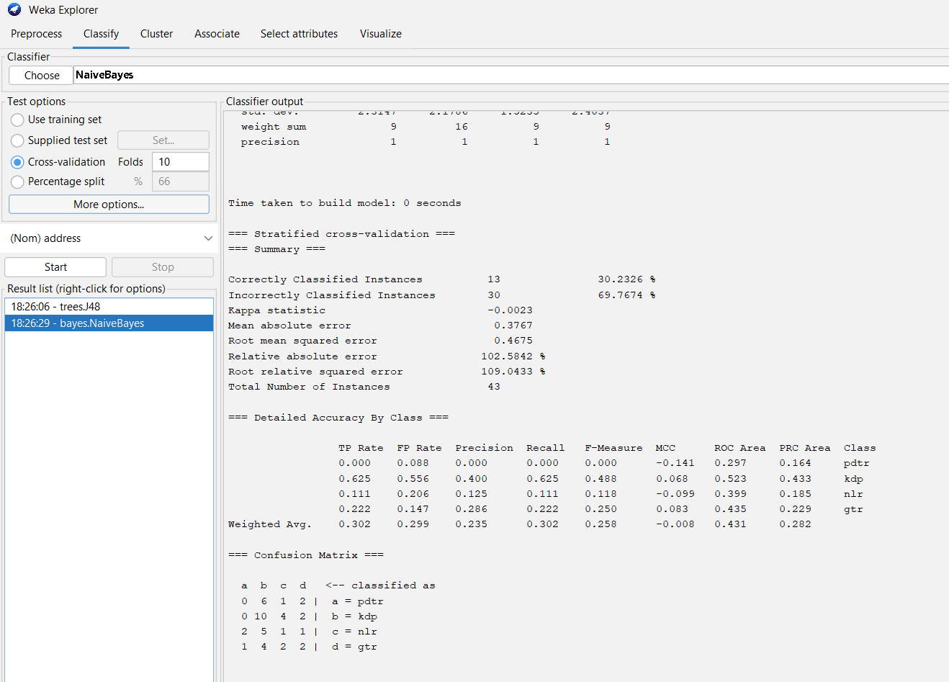

**xi) Apply Apriori, Interpret the results.**

* Go to **Associate** tab.
* Choose **Apriori**.
* Click **Start**.
* Interpret frequent itemsets, rules generated.

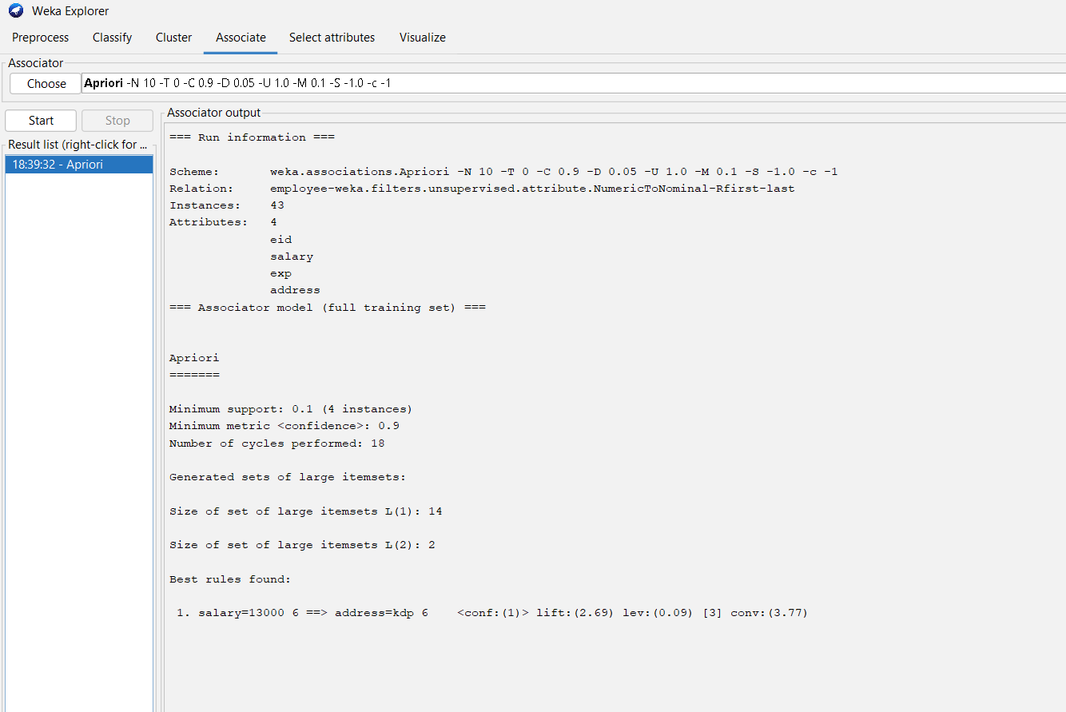

**xii) Apply Association rules and interpret the results.**

* In Associate tab, Apriori shows association rules.
* Analyze rules with high confidence and support.
* Example: Salary = 15000 → Address = nlr (confidence 80%).

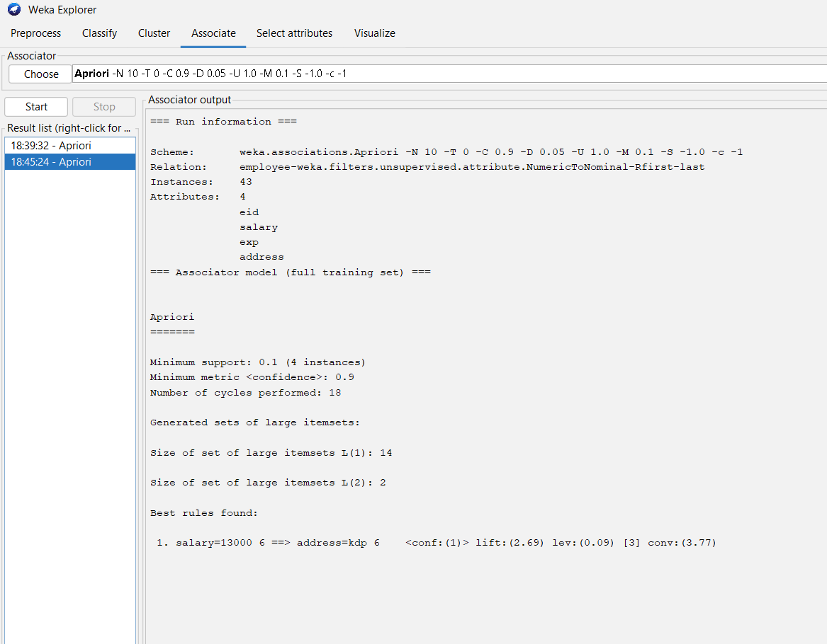

**Analysis of Association Rules:**

* Used the Apriori algorithm in WEKA to generate association rules.
* Focused on rules with high confidence and support to identify strong relationships.
* Example: Salary = 15000 → Address = NLR (confidence = 80%)
* Indicates that employees earning ₹15,000 are highly likely (80%) to live in NLR.
* Association rules help in identifying patterns and correlations in the dataset.
* Apriori efficiently discovered frequent itemsets and produced interpretable rules.

**xiii) Apply Association mining with the Apriori alforithm and find the best rules with threshold value of support of 50% and confidence of 70%.**

* Configure Apriori parameters:
* minSupport = 0.5
* minMetric (confidence) = 0.7
* Click Start.
* View best rules that satisfy thresholds.

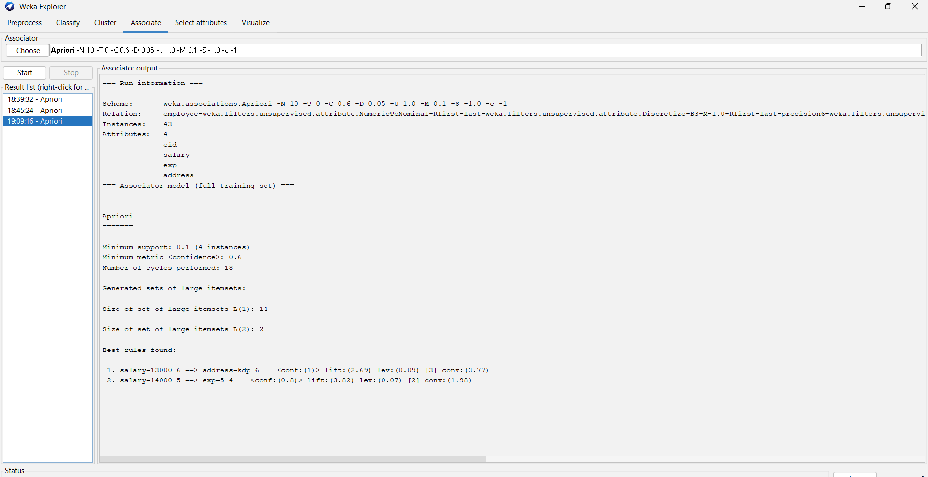

**Steps to fix in WEKA**

1. Remove the eid attribute.
2. Discretize salary and exp into 3–4 bins.
3. Open **Apriori**:
   * **minSupport = 0.1**
   * **minMetric = 0.6**
   * **numRules = 10–20**
4. Click **Start** → you should see **rules like**:
   * Salary=13500-15000 → Address=nlr
   * Exp=5-7 → Address=kdp

**xiv) Interpret the results obtained at Summary. Analyse Precision, Recall, F Score values.**

**After classification runs:**

* Check Classify output for Precision, Recall, F-Measure.
* Analyze which classes perform best.
* Summarize trade-offs (e.g., high precision but low recall).

**Classification Analysis**

* Check **Precision, Recall, F1-Score** in WEKA after classification.
* **Precision** → % of correct predictions for a class (high = fewer false positives).
* **Recall** → % of actual instances correctly identified (high = most positives captured).
* **F1-Score** → balance between precision and recall.
* Analyze **which classes perform best** and which perform poorly.
* **Trade-offs**:
  + High precision, low recall → strict, fewer predictions but mostly correct.
  + High recall, low precision → many predictions but more errors.
* Use these metrics to **evaluate model performance** and guide improvements.

**xv) Install R package at Weka environment and install rpart package. Implement decision tree.**

**Step 1: Install R on your system**

1. Download R from CRAN.
2. Install it with default settings.
3. Remember the installation path (you’ll need it for WEKA).

**Step 2: Install RPlugin in WEKA**

1. Open **WEKA GUI**.
2. Go to **Tools → Package Manager**.
3. In the search box, type **RPlugin**.
4. Click **Install** and wait for it to finish.
5. Restart WEKA to activate the plugin.

**Step 3: Install rpart package in R**

1. Open the **R console**.
2. Run:
3. install.packages("rpart")
4. Wait for the package to install. You can check by running:
5. library(rpart)

**Step 4: Configure WEKA to use R**

1. In WEKA, go to **Tools → Options → R Plugin**.
2. Set the **path to your R executable** (e.g., C:\Program Files\R\R-4.4.2\bin\R.exe).
3. Click **Apply** and **OK**.

**Step 5: Implement Decision Tree in WEKA**

1. Load your dataset in WEKA.
2. Go to **Classify** tab.
3. Click **Choose → trees → RPart**.
4. Set options if needed (e.g., min split, cp).
5. Click **Start** to run the classifier.

**Step 6: View Output**

* After running, you’ll see:
  + **Decision tree structure**
  + **Classification accuracy**
  + **Class-wise metrics** (Precision, Recall, F-Score)